**Ideation Phase**

**Define the Problem Statements**

|  |  |
| --- | --- |
| Date | 19 September 2022 |
| Team ID | PNT2022TMIDxxxxxx |
| Project Name | Project - Real-Time Communication System Powered by AI for Specially Abled |
| Maximum Marks | 2 Marks |

**Customer Problem Statement Template:**

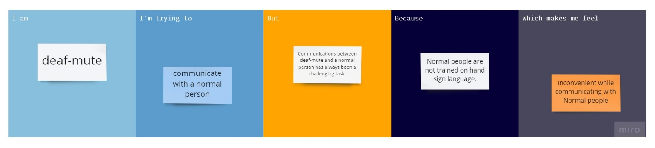

|  |  |  |  |  |  |
| --- | --- | --- | --- | --- | --- |
| **Problem Statement (PS)** | **I am (Customer)** | **I’m trying to** | **But** | **Because** | **Which makes me feel** |
| PS-1 | Deaf-mute | Communicate with the normal people | Communication between deaf-mute and a normal person is always a difficult task. | It is not possible that every normal person can understand the hand sign language. | Inconvenience while communicating with a normal person. |
| PS-2 | Normal person | Communicate with a specially abled people (Deaf-mute) | In emergency times conveying their message to the opponent is very difficult. | It is not possible to convey the message in a proper way. | Hard to deliver the content. |